UNITED STATES

SECURITIES AND EXCHANGE COMMISSION

Washington, D.C. 20549

FORM 8-K

CURRENT REPORT

PURSUANT TO SECTION 13 OR 15(d) OF THE SECURITIES EXCHANGE ACT OF 1934

Date of report (Date of earliest event reported): June 27, 2023

Liberty Global plc

(Exact Name of Registrant as Specified in Charter)

England and Wales | 001-35961 | 98-1112770
(State or other jurisdiction | (Commission File Number) | (IRS Employer
of incorporation) |  | Identification #)

Griffin House, 161 Hammersmith Rd, London, United Kingdom

W6 8BS

(Address of Principal Executive Office)

+44.208.483.6449 or 303.220.6600

(Registrant’s telephone number, including area code)

 | Securities registered pursuant to Section 12(b) of the Act:
Title of each class | Trading Symbol(s) | Name of each exchange on which registered
Class A ordinary shares | LBTYA | Nasdaq Global Select Market
Class B ordinary shares | LBTYB | Nasdaq Global Select Market
Class C ordinary shares | LBTYK | Nasdaq Global Select Market

Check the appropriate box below if the Form 8-K filing is intended to simultaneously satisfy the filing obligation of the registrant under any of the following provisions:

- Written communications pursuant to Rule 425 under the Securities Act (17 CFR 230.425)

- Soliciting material pursuant to Rule 14a-12 under the Exchange Act (17 CFR 240.14a-12)

- Pre-commencement communications pursuant to Rule 14d-2(b) under the Exchange Act (17 CFR 240.14d-2(b))

- Pre-commencement communications pursuant to Rule 13e-4(c) under the Exchange Act (17 CFR 240.13e-4(c))

Indicate by check mark whether the registrant is an emerging growth company as defined in Rule 405 of the Securities Act of 1933 (§230.405 of this chapter) or Rule 12b-2 of the Securities Exchange Act of 1934 (§240.12b-2 of this chapter).

Emerging growth company ☐

If an emerging growth company, indicate by check mark if the registrant has elected not to use the extended transition period for complying with any new or revised financial accounting standards provided pursuant to Section 13(a) of the Exchange Act. ☐

Item 7.01 REGULATION FD DISCLOSURES

On June 27, 2023, Liberty Global plc (“Liberty Global”, “we”, “our”), one of the world’s leading converged video, broadband and mobile communications companies, issued a press release (the “Press Release”) noting the support of Glass Lewis, a proxy advisory services firm, of our proposed change of jurisdiction of incorporation of our parent holding company to Bermuda from England & Wales (the “Redomiciliation”). On June 28, 2023, Liberty Global also provided additional investor materials (the “Materials”) regarding the Redomiciliation to shareholders and began providing sponsored advertisements for certain web searches on major search engines (the “Advertisements”). The Press Release, the Materials and the Advertisements are attached as Exhibit 99.1, Exhibit 99.2 and Exhibit 99.3, respectively, to this report and incorporated herein by reference.

Forward-Looking Statements

This communication contains certain statements which are, or may be deemed to be, “forward-looking statements” with respect to the financial condition, results of operations and business of Liberty Global and certain plans and objectives of Liberty Global with respect to the Redomiciliation. All statements other than statements of historical fact may be forward-looking statements. Forward-looking statements are statements of future expectations that are based on current expectations, assumptions and projections about future events and are therefore subject to risks and uncertainties which could cause actual results, performance or events to differ materially from those expressed or implied by the forward-looking statements. Often, but not always, forward-looking statements can be identified by the use of forward-looking words such as “plans”, “expects”, “is expected”, “is subject to”, “budget”, “scheduled”, “estimates”, “forecasts”, “intends”, “anticipates”, “believes”, “targets”, “aims”, “projects” or words or terms of similar substance or the negative thereof, as well as variations of such words and phrases or statements that certain actions, events or results “may”, “could”, “should”, “would”, “might” or “will” be taken, occur or be achieved. Such statements are qualified in their entirety by the inherent risks and uncertainties surrounding future expectations.

Although Liberty Global believes that the expectations reflected in such forward-looking statements are reasonable, we cannot give assurance that such expectations will prove to be correct. By their nature, forward-looking statements involve risk and uncertainty because they relate to events and depend on circumstances that will occur in the future. There are a number of factors that could cause actual results and developments to differ materially from those expressed or implied by such forward-looking statements, including, but not limited to, the matters set forth under “Forward Looking Statements” in Part I, Item 1 of Liberty Global’s Annual Report on Form 10-K for the fiscal year ended December 31, 2022 and in Part I, Item 2 of Liberty Global’s Quarterly Reports on Form 10-Q for the fiscal quarter ended March 31, 2023. Other factors that could cause actual results and developments to differ materially from those expressed or implied by such forward-looking statements include our ability to obtain the approval of Liberty Global shareholders for the Redomiciliation and the resolutions proposed at related meetings of holders of our Class A Ordinary Shares, Class B Ordinary Shares and Class C Ordinary Shares, our ability to satisfy the other conditions to the Redomiciliation on the expected timeframe, or at all, our ability to realize the expected benefits from the Redomiciliation and the occurrence of unanticipated difficulties or costs in connection with the Redomiciliation.

All of our forward-looking statements should be considered in light of these factors. All of our forward-looking statements speak only as of the date they were made, and we undertake no obligation to update our forward-looking statements or risk factors to reflect new information, future events or otherwise, except as may be required under applicable securities laws and regulations. Accordingly, you should not place undue reliance on any such forward-looking statements.

Additional Information and Where to Find It

This communication does not constitute an offer to sell or the solicitation of an offer to buy any securities or a solicitation of any vote or approval. This communication may be deemed to be solicitation material in respect of the Redomiciliation. In connection with the Redomiciliation, on June 9, Liberty Global filed with the SEC a definitive proxy statement on Schedule 14A and scheme circulate (the “Definitive Proxy Statement”). LIBERTY GLOBAL SHAREHOLDERS ARE URGED TO READ THE DEFINITIVE PROXY STATEMENT AS WELL AS ANY AMENDMENTS OR SUPPLEMENTS THERETO AND ANY DOCUMENTS INCORPORATED BY REFERENCE THEREIN AND OTHER RELEVANT DOCUMENTS IN CONNECTION WITH THE PROPOSED TRANSACTION THAT LIBERTY GLOBAL WILL FILE WITH THE SEC WHEN THEY BECOME AVAILABLE BECAUSE THEY WILL CONTAIN IMPORTANT INFORMATION ABOUT THE REDOMICILATION. Liberty Global shareholders and investors may obtain free copies of the Definitive Proxy Statement and other relevant materials (when they become available) and other documents filed by Liberty Global at the SEC’s website at www.sec.gov. Copies of the Definitive Proxy Statement (and other relevant materials when they become available) and the filings that will be incorporated by reference therein may also be obtained, without charge, by contacting Liberty Global’s Investor Relations at ir@libertyglobal.com or +1(303) 220-6600.

Participants in Solicitation

Liberty Global and its directors, executive officers and certain employees, may be deemed, under SEC rules, to be participants in the solicitation of proxies in respect of the proposed Redomiciliation. Information regarding Liberty Global’s directors and executive officers is available in its Definitive Proxy Statement filed with the SEC on June 9, 2023. Other information regarding the participants in the proxy solicitation and a description of their direct and indirect interests, by security holdings or otherwise, are contained in the Definitive Proxy Statement and will be contained in other relevant materials to be filed with the SEC (when they become available). These documents can be obtained free of charge from the sources indicated above.

Item 9.01 Financial Statements and Exhibits.

- Exhibits.

Exhibit No. |  |  |  |  |  | Exhibit Name
99.1* |  |  | Press Release, dated June 27, 2023
99.2* |  |  | Investor Materials
99.3* |  |  | Sponsored Advertisements
101.SCH |  |  | Inline XBRL Taxonomy Extension Schema Document
101.DEF |  |  | Inline XBRL Taxonomy Extension Definition Linkbase Document
101.LAB |  |  | Inline XBRL Taxonomy Extension Label Linkbase Document
101.PRE |  |  | Inline XBRL Taxonomy Extension Presentation Linkbase Document

  - Cover Page Interactive Data File (formatted as Inline XBRL and contained in Exhibit 101) * Exhibit is furnished herewith and not deemed to be filed.

SIGNATURE

Pursuant to the requirements of the Securities Exchange Act of 1934, the registrant has duly caused this report to be signed on its behalf by the undersigned hereunto duly authorized.

LIBERTY GLOBAL PLC

By: /s/ RANDY L. LAZZELL

Randy L. Lazzell

Vice President

Date: June 28, 2023

Exhibit 99.1


INDEPENDENT PROXY ADVISOR GLASS LEWIS RECOMMENDS SHAREHOLDERS VOTE FOR ALL PROPOSALS RELATED TO LIBERTY GLOBAL’S CHANGE OF INCORPORATION

GLASS LEWIS STATES “WE AGREE WITH THE BOARD’S RATIONALE THAT THE CHANGE IN DOMICILE IS IN THE BEST INTERESTS OF SHAREHOLDERS”

Denver, Colorado – June 27, 2023

Liberty Global plc (“Liberty Global”) (NASDAQ: LBTYA, LBTYB and LBTYK) today announced that in its report issued June 23, 2023, independent proxy advisory firm Glass, Lewis & Co. (“Glass Lewis”) has recommended that Liberty Global’s shareholders vote for all of the Company’s proposals in connection with Liberty Global’s intention to change its place of incorporation from England & Wales to Bermuda.

In its report, Glass Lewis concluded, “On balance, we agree with the board's rationale that the change in domicile is in the best interests of shareholders.”

Commenting on the Glass Lewis recommendation, Liberty Global stated the following:

“Liberty Global appreciates Glass Lewis’ support for our proposal to change our incorporation from England & Wales to Bermuda. The principal reasons for the proposal are to enable future shareholder value creation by moving to a jurisdiction that makes it substantially easier to facilitate corporate transactions, such as buy-backs and self-tender offers, spin offs and split offs and reduce administrative burdens and expense, while maintaining robust shareholder rights and protections. We remain committed to our UK and European customers, employees and businesses, Bermuda’s U.S.-style governance is more aligned with the expectations of our largely U.S. shareholder base.”

The redomiciliation would change the jurisdiction of incorporation and governing documents of the parent company, but would have no effect on Liberty Global’s operations and subsidiaries:

- The transaction is not tax-driven; Liberty Global’s revenue and income would remain European-based, and its subsidiaries’ tax residence will not change.

- As a Bermuda company, Liberty Global will continue trading on Nasdaq (under the symbols LBTYA, LBTYB and LBTYK) and will continue to be governed by SEC rules and regulations.

- Liberty Global’s day-to-day operations in all its businesses, including its joint ventures in the U.K. and the Netherlands, will be unaffected.

- There will be no change in Liberty Global’s offices or headquarters, management team, board of directors or employee base and no changes to our customer services and products.

- There will be no material change in Liberty Global’s financial statements and no changes in its financial documents, financings, bonds or credit agreements. Liberty Global’s Board of Directors urges shareholders to vote for all of its proposals related to its change of incorporation.

ABOUT LIBERTY GLOBAL

Liberty Global (NASDAQ: LBTYA, LBTYB and LBTYK) is a world leader in converged broadband, video and mobile communications services. We deliver next-generation products through advanced fiber and 5G networks, and currently provide over 86 million connections* across Europe and the United Kingdom. Our businesses operate under some of the best-known consumer brands, including Virgin Media-O2 in the U.K., VodafoneZiggo in The Netherlands, Telenet in Belgium, Sunrise in Switzerland, Virgin Media in Ireland and UPC in Slovakia. Through our substantial scale and commitment to innovation, we are building Tomorrow’s Connections Today, investing in the infrastructure and platforms that empower our customers to make the most of the digital revolution, while deploying the advanced technologies that nations and economies need to thrive.

Our consolidated businesses generate annual revenue of more than $7 billion, while the VMO2 JV and VodafoneZiggo JV generate combined annual revenue of more than $17 billion.**

Liberty Global Ventures, our global investment arm, has a portfolio of more than 75 companies across content, technology and infrastructure, including strategic stakes in companies like ITV, Televisa Univision, Plume, AtlasEdge and the Formula E racing series.

* Represents aggregate consolidated and 50% owned non-consolidated fixed and mobile subscribers. Includes wholesale mobile subscribers of the VMO2 JV and B2B fixed subscribers of the VodafoneZiggo JV.

- Revenue figures above are provided based on full year 2022 Liberty Global consolidated results (excluding revenue from Poland) and the combined as reported full year 2022 results for the VodafoneZiggo JV and full year 2022 U.S. GAAP results for the VMO2 JV. For more information, please visit www.libertyglobal.com.

Investor Relations

Corporate Communications

Michael Bishop +44 20 8483 6246

Bill Myers +1 303 220 6686

Amy Ocen +1 303 784 4528

Matt Beake +44 20 8483 6428

Michael Khehra +44 78 9005 0979

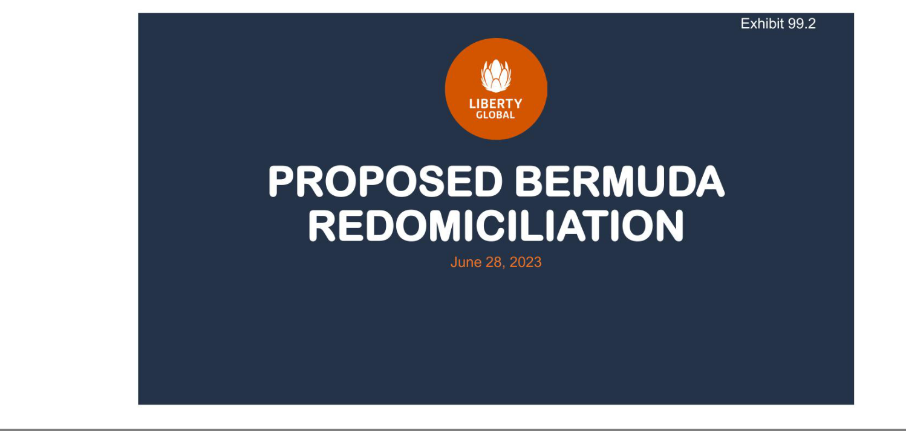

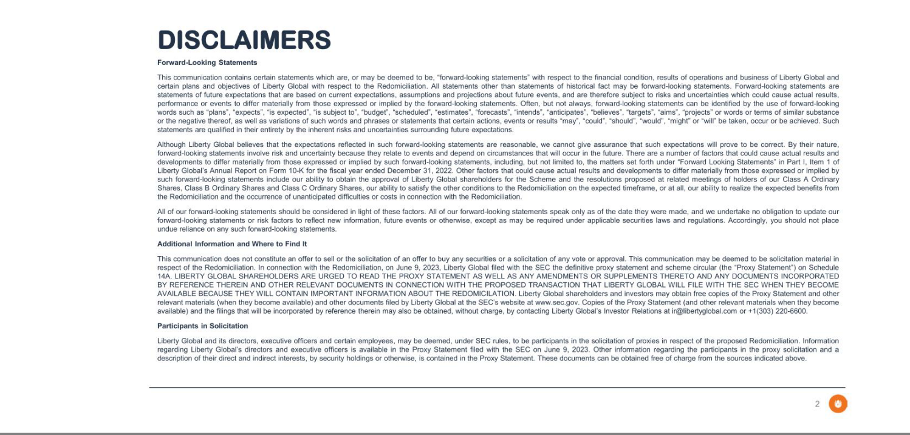

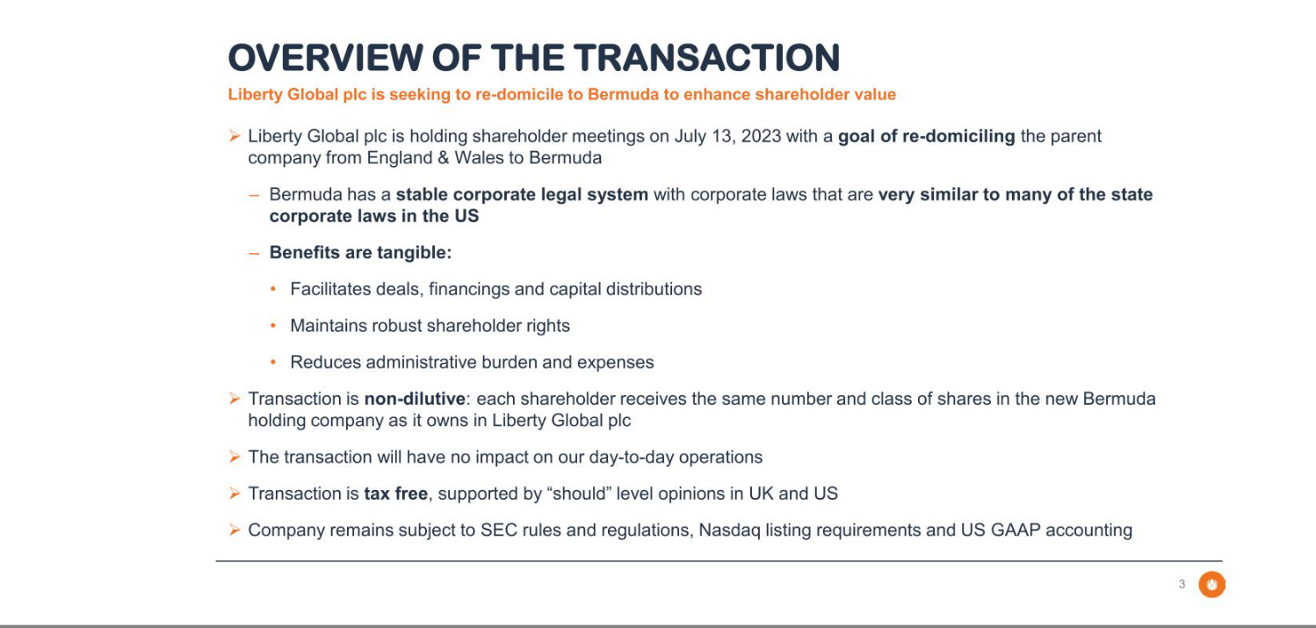

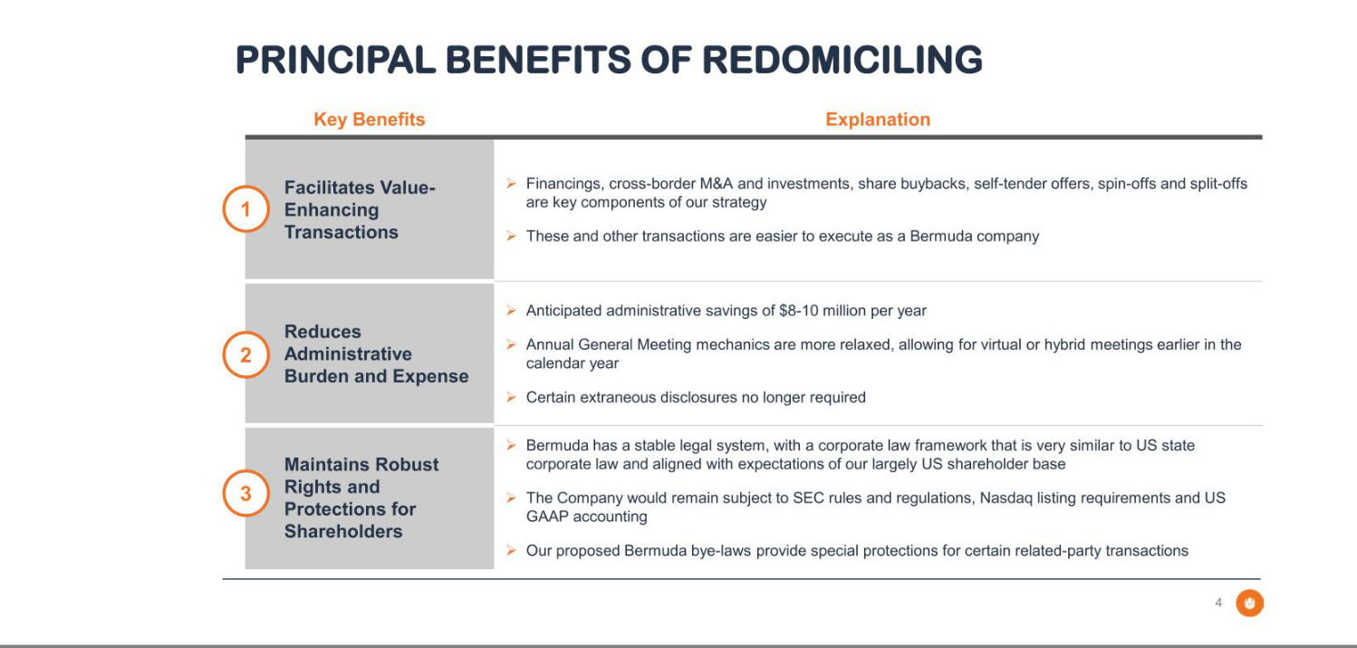

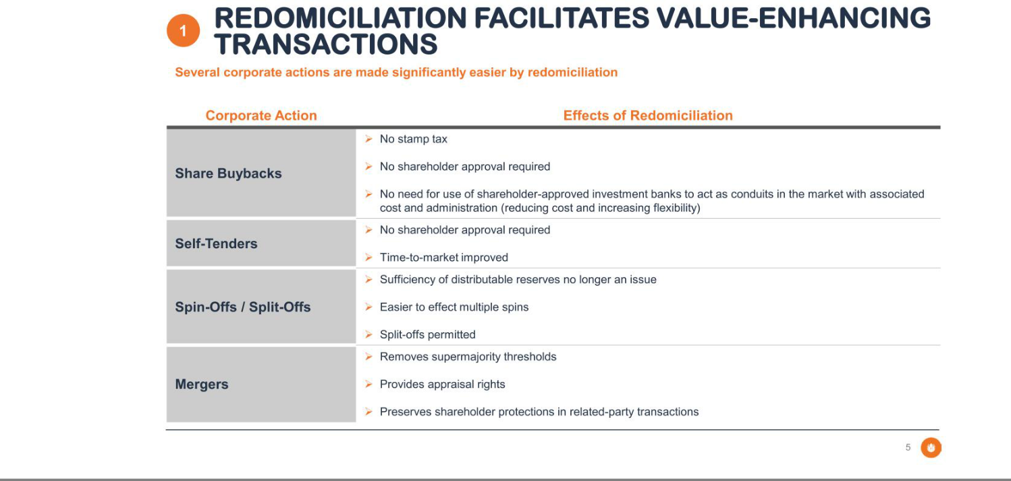

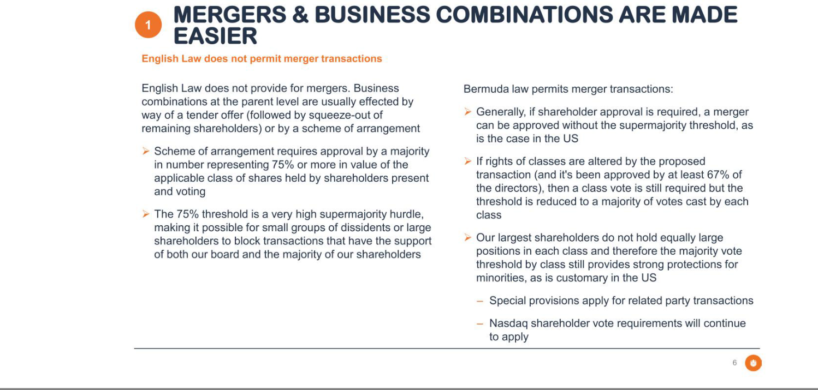

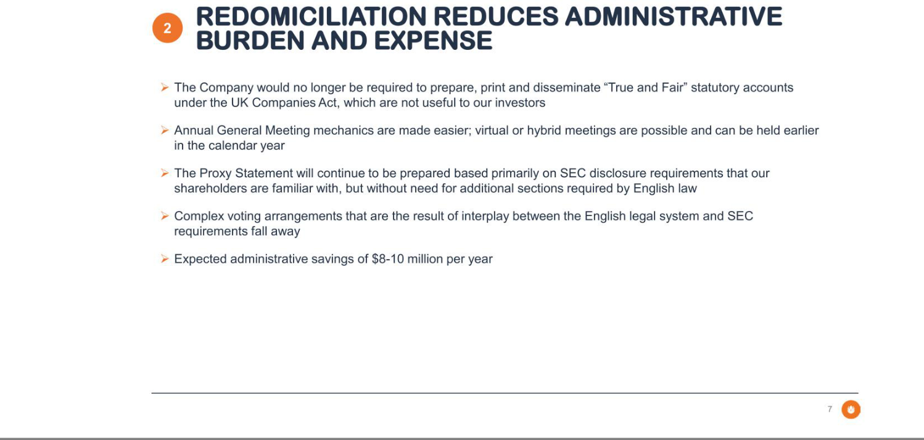

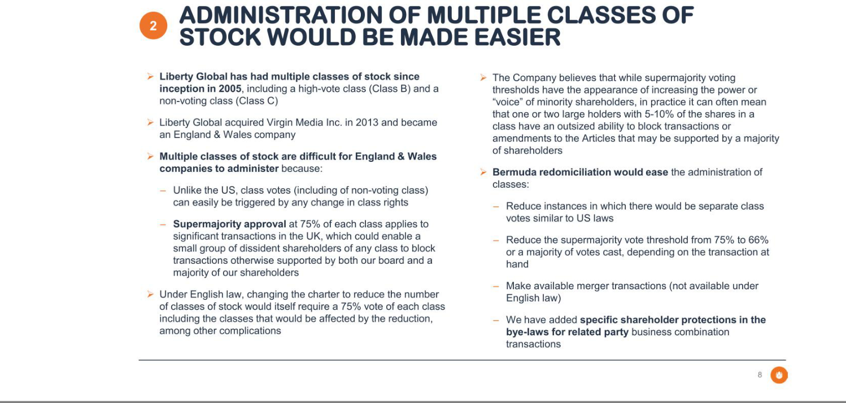

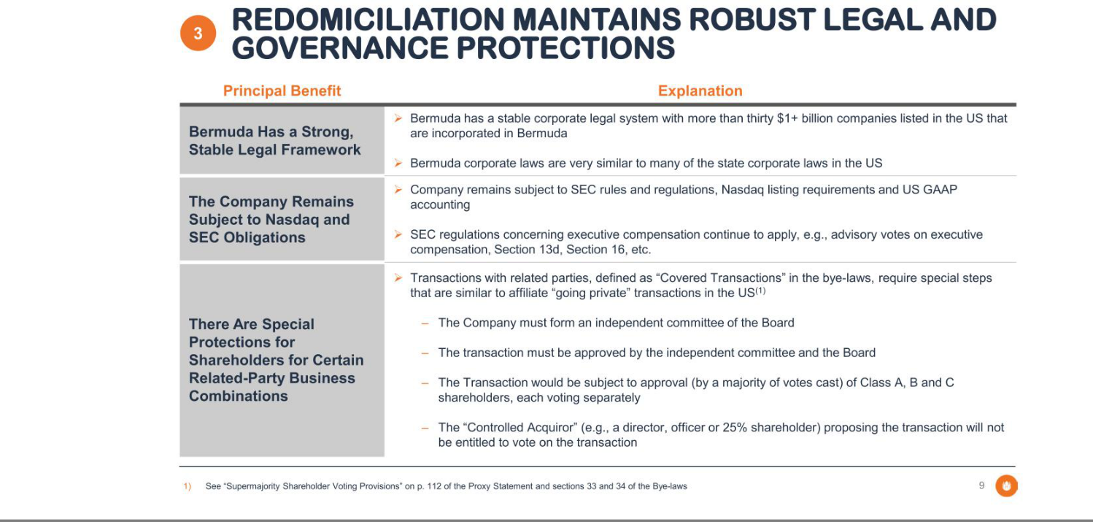

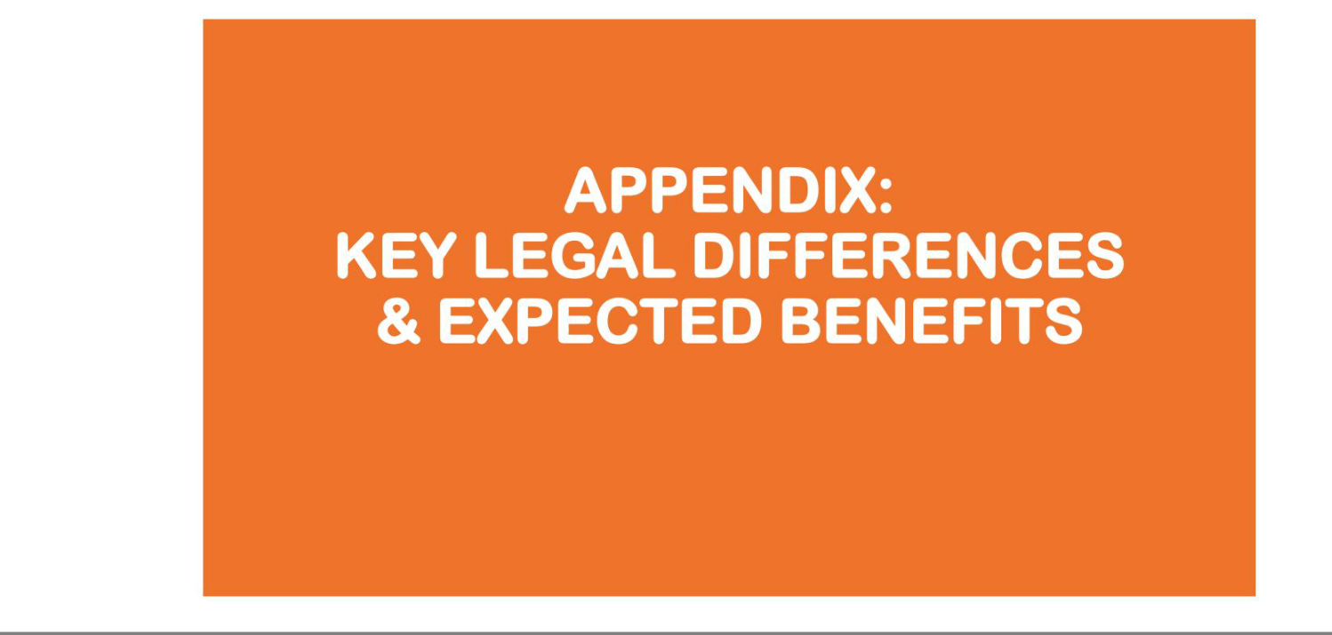

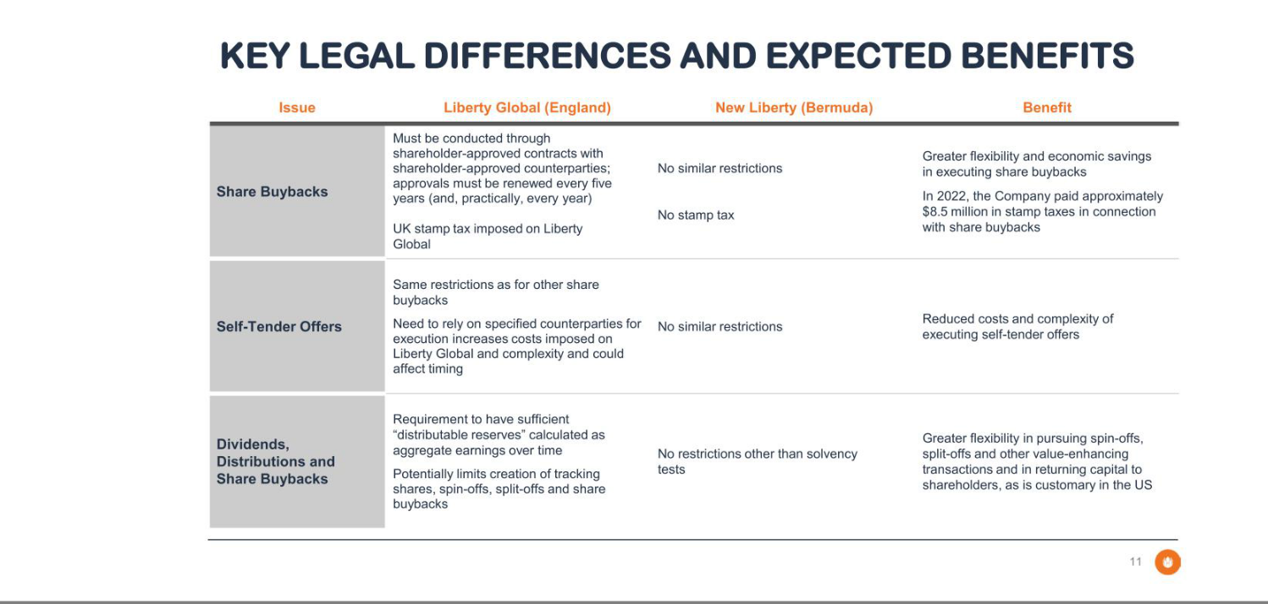

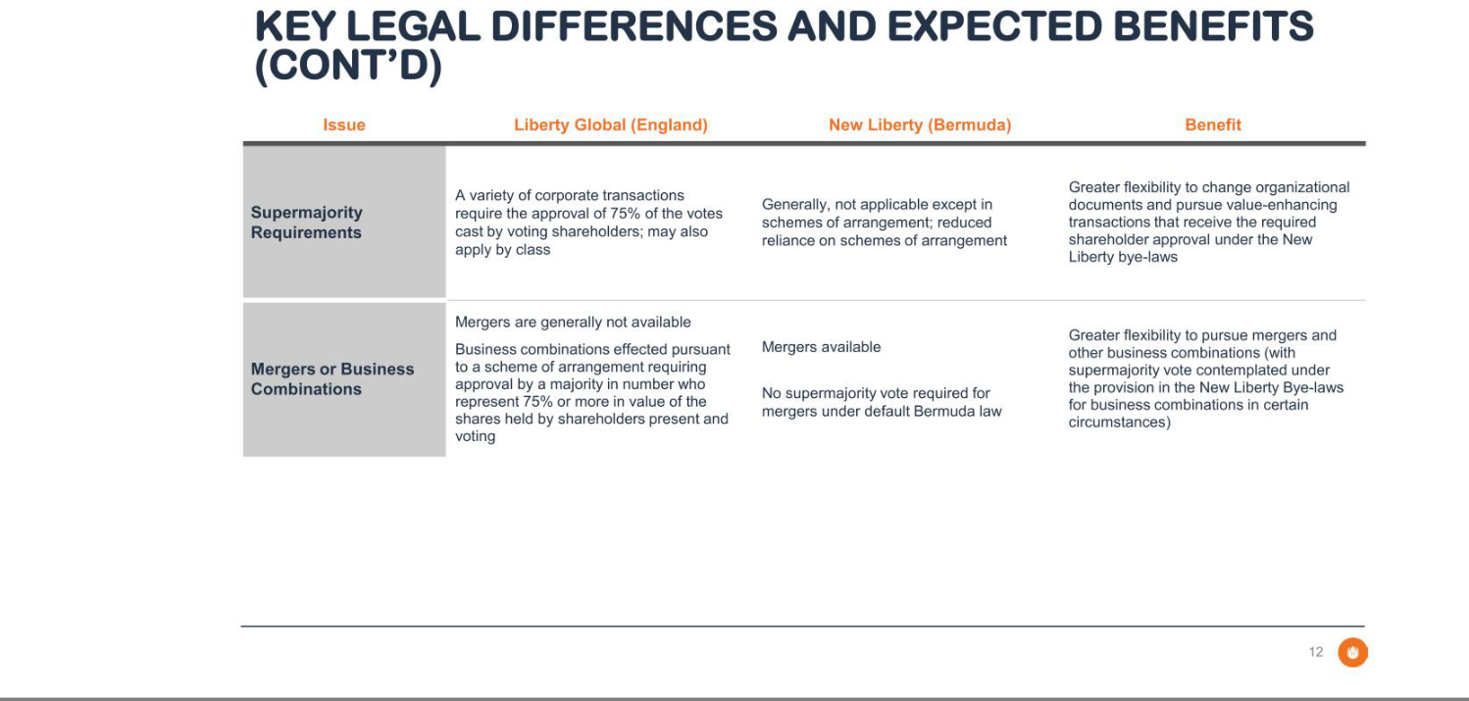

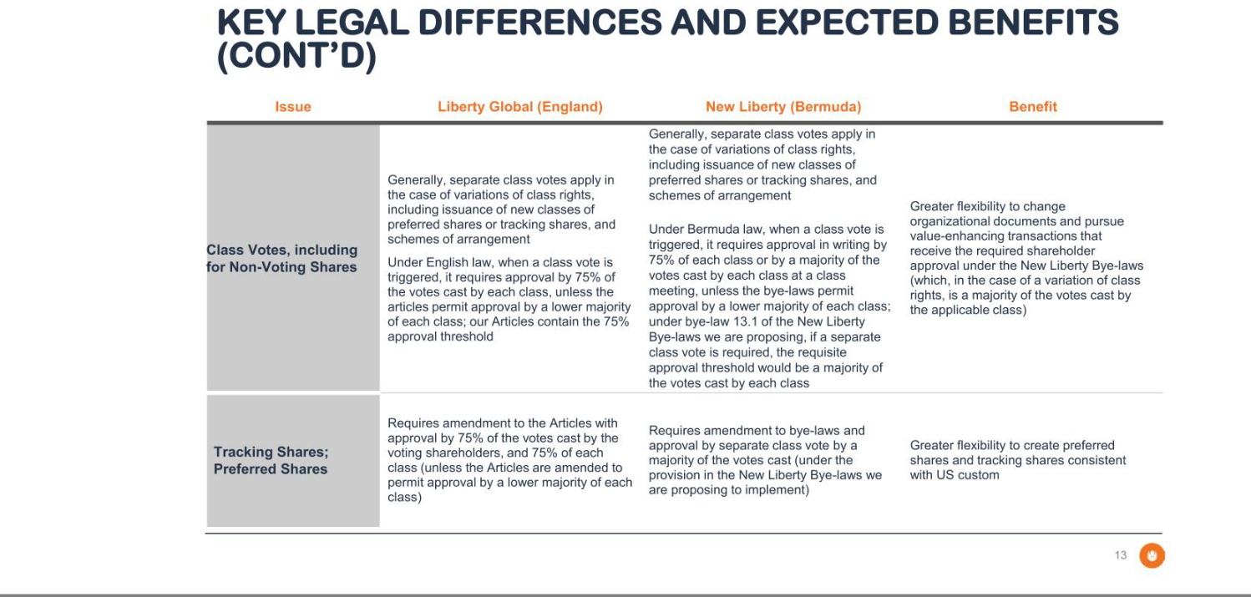

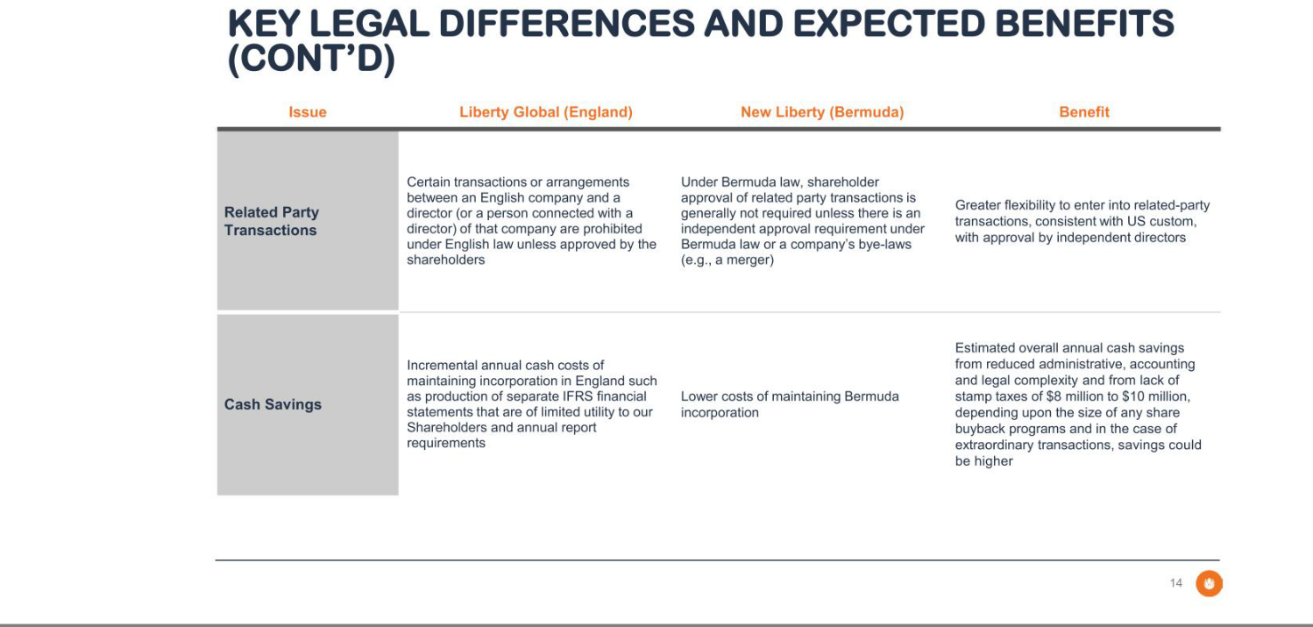

Exhibit 99.3


